EU DECLARATION OF CONFORMITY NO.: GZPH ICR14500-800
Product: | Rechargeable Li-ion Cell
Battery category: | Portable Battery
Battery model identification: | ICR14500
Battery serial number: | 20260704
Battery IEC code: | ICR15/51
Battery place of manufacture: | Panyu District, Guangzhou, Guangdong Province, China
Battery date of manufacture: | Determine the production date based on the label's 20260704
Battery weight: | ≈20g
Battery rated capacity: | 800mAh
Battery nominal Voltage: | 3.7V
Battery electrochemical composition: | Li-ion LCO
Battery hazardous substances, other than cadmium and lead: | None
Battery usable extinguishing agent: | Water, Water-based fire extinguisher
Battery critical raw materials: | aluminium, cobalt, copper，lithium，manganese, graphite，nickel
Manufacturer’s name: | Guangzhou Great Power Energy & Technology Co., Ltd.
Manufacturer’s address: | No. 912, West Village Segment, Shiliang Road, Shawan Town, Panyu District, Guangzhou City, Guangdong Province 511483 P. R. China
Manufacturer’s web: | http://www.greatpower.net
Manufacturer’s email: | info@greatpower.net
Authorised representative (Name and address): | N/A
Manufacturer's statement: | This declaration of conformity is issued under the sole responsibility of the manufacturer.
Object of the declaration: | Description of the battery and identification allowing traceability  ICR14500, 3.7V,800mAh 2,96Wh  Label:  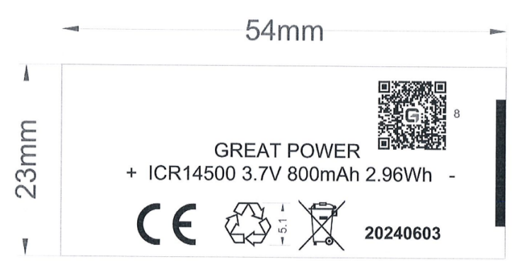  Image of battery:
We, Guangzhou Great Power Energy & Technology Co., Ltd. declare under our sole responsibility that the above referenced product is in conformity with the applicable requirements of the following Regulations:
EU Battery Regulation: (EU) 2023/1542
Conformity with these directives has been assessed for the product by demonstrating compliance to the following technical specifications/standards and/or regulations:
IEC 62133-2:2017/AMD1:2021
(EU)2023/1542
(EC) No 1907/2006 and (EU) 2023/1464 Annex XVII

Signed for and on behalf of: Guangzhou Great Power Energy & Technology Co., Ltd.
Place: Guangzhou, Guangdong, China Date: 2026-07-04
Name: chen jianquan Position: sales manager
Signature: chen jianquan

